Model Design

Generally, the Gardening Assistant application’s overall purpose is to assist users, both professionals and hobbyists, with creating/maintaining a garden. However, to be more specific, the application provides assistance through the app’s functions, for example:

When starting the application for the first time, users can create their own account in order to utilise the app to its maximum capability. By signing into their account, users can also access the *‘Forum*’ feature of the application, where they can post questions posted by the community of users (or answer previously posted questions).

Users can utilise the app’s ‘*Drawing Tool*’ to plan a layout of what the garden will visually look like, by displaying a 3D canvas over their gardening space (which is achieved by using their camera) and dragging/arranging chosen plants over that canvas to create a virtual representation of what their garden could look like in reality.

In addition to this, they have the option to save any of the designs they create to a repository unique to their account called: ‘*MyGarden*’. This function is essentially a folder for all the garden designs a user may create, meaning, that user has the freedom to open previously made designs, edit those designs or even delete them if they no longer need them.

As previously mentioned, hobbyists are some of our intended stakeholders/target audience, and these people may not have the same specialist knowledge that professionals do, therefore, a key feature of this application is a ‘*Database*’. This database is run by administrators who frequently update an organised source of information regarding a wide range of different plants, vegetables, etc. Therefore, users who aren’t knowledgeable on plants but still want to maintain a garden can use this database to research their plant of choice on how to best maintain it.

Finally, users can use the ‘*Calendar Tool*’ to plan out their garden maintenance for months in advance. Depending on the plants they’ve chosen, the application, as well as, themselves can place reminders on specific dates relating to things they have to do. And depending on their settings, these reminders will appear as notifications on their devices.

Prototypes

After we created and unanimously agreed upon our design, a low-fidelity prototype was created. This prototype detailed the various screens of the application, including how to use the software and how to navigate between screens. It wasn’t functional; however, it provided a rough idea of what we envisioned the final product to resemble. Therefore, after finishing development of the low fidelity prototype, it was immediately tested on stakeholders so we could receive feedback to evaluate on its pros and cons before starting development of the high-fidelity (functional) prototype.

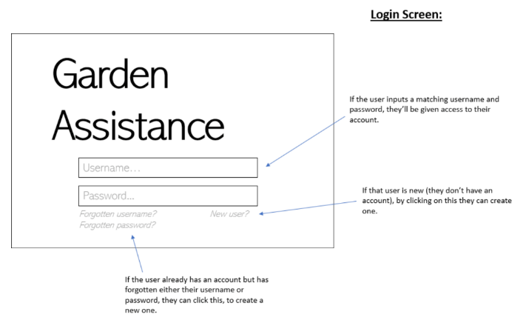

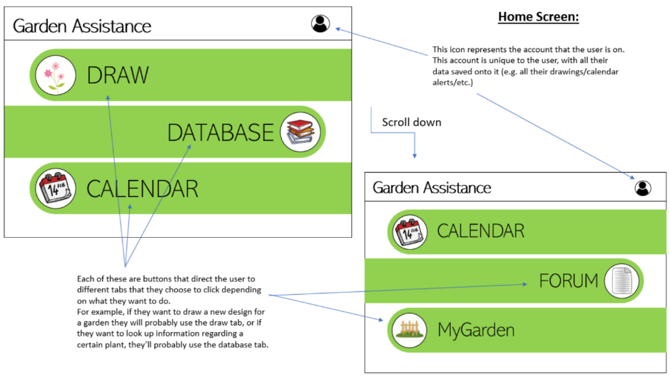

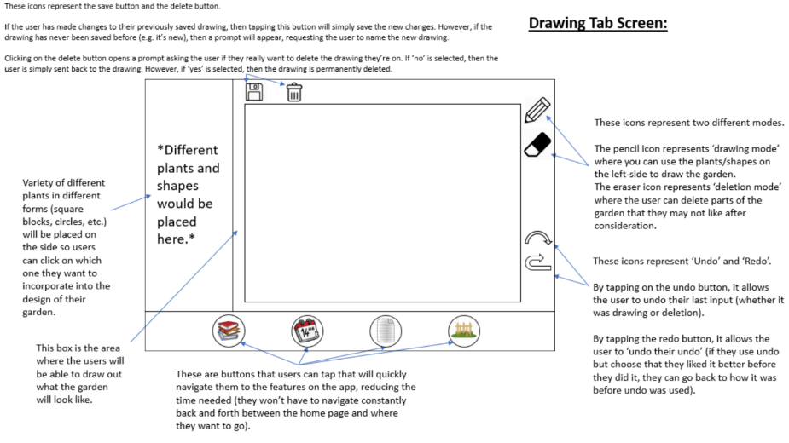

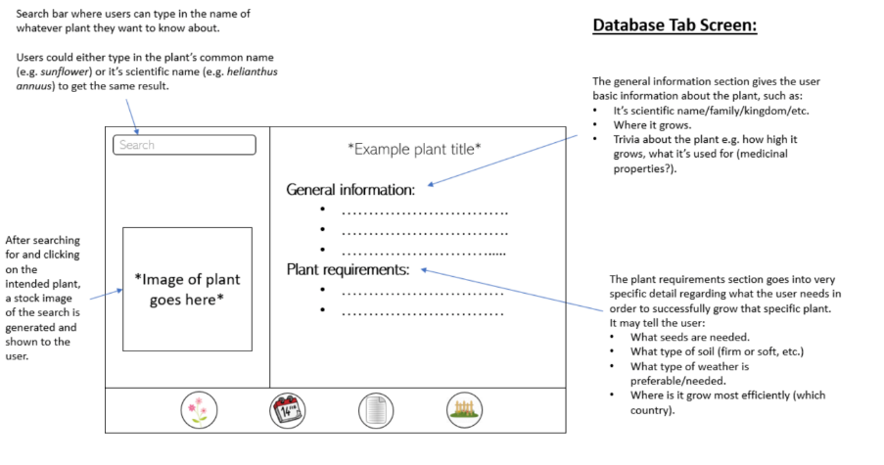

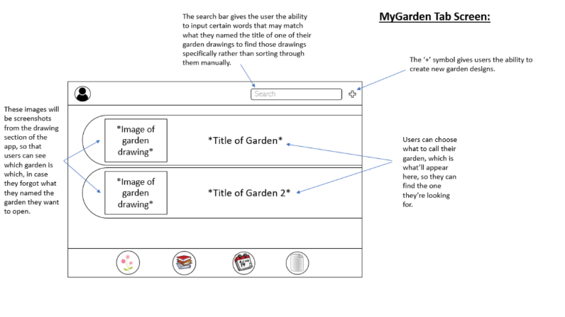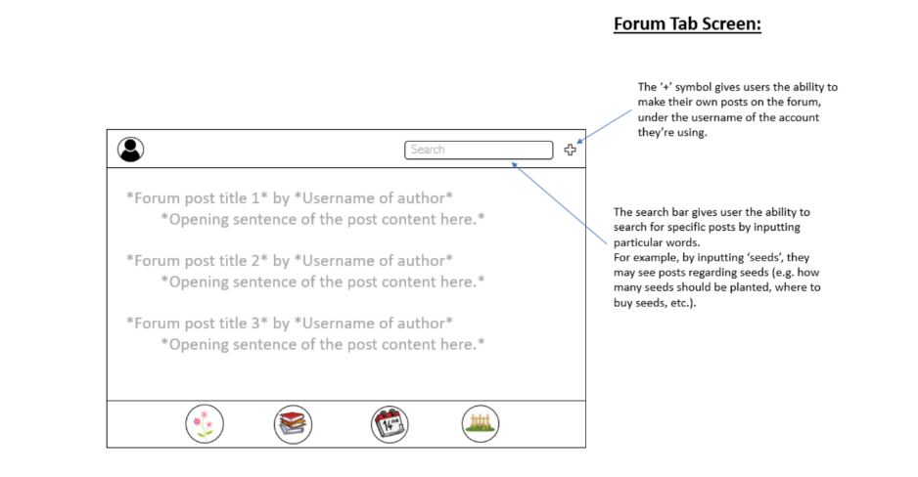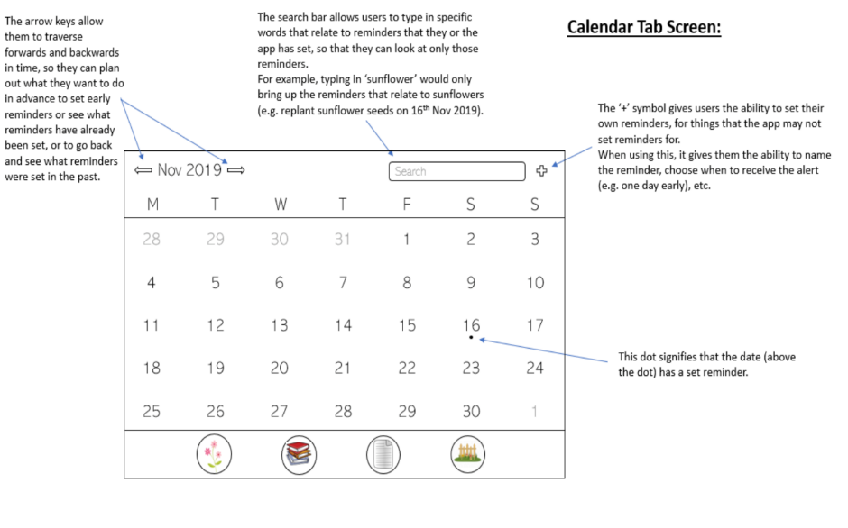

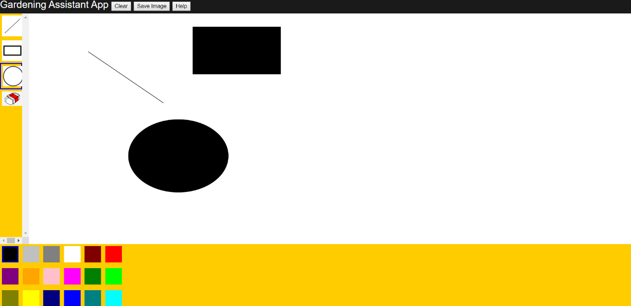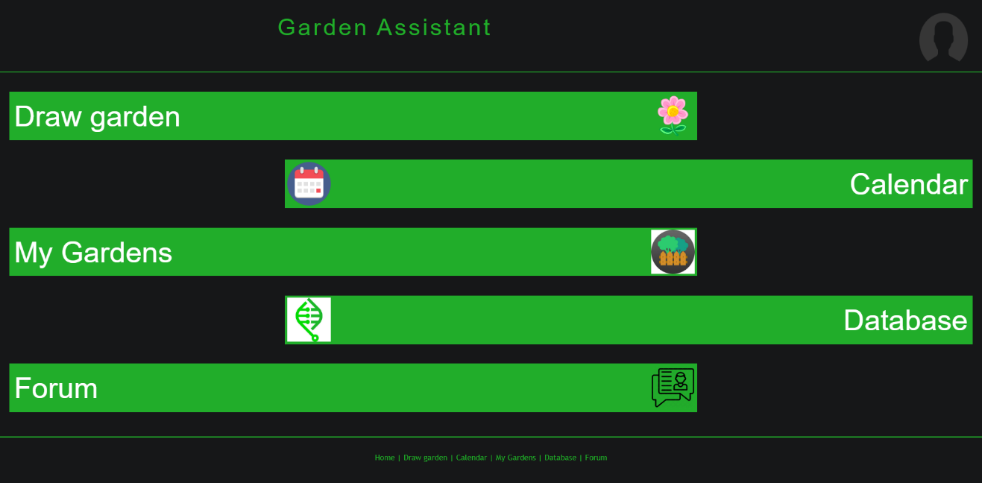This prototype was a vastly more functional replication of the low-fidelity prototype. This version allowed for users to navigate through pages. However, using the feedback from our low-fidelity prototype, we decided to update our drawing tool, which was originally a simple 2D-drag-and-drop tool to our current tool which utilises a 3D canvas and camera function. Although, this change wasn’t implemented until we made our final prototype: the high-fidelity technical prototype.

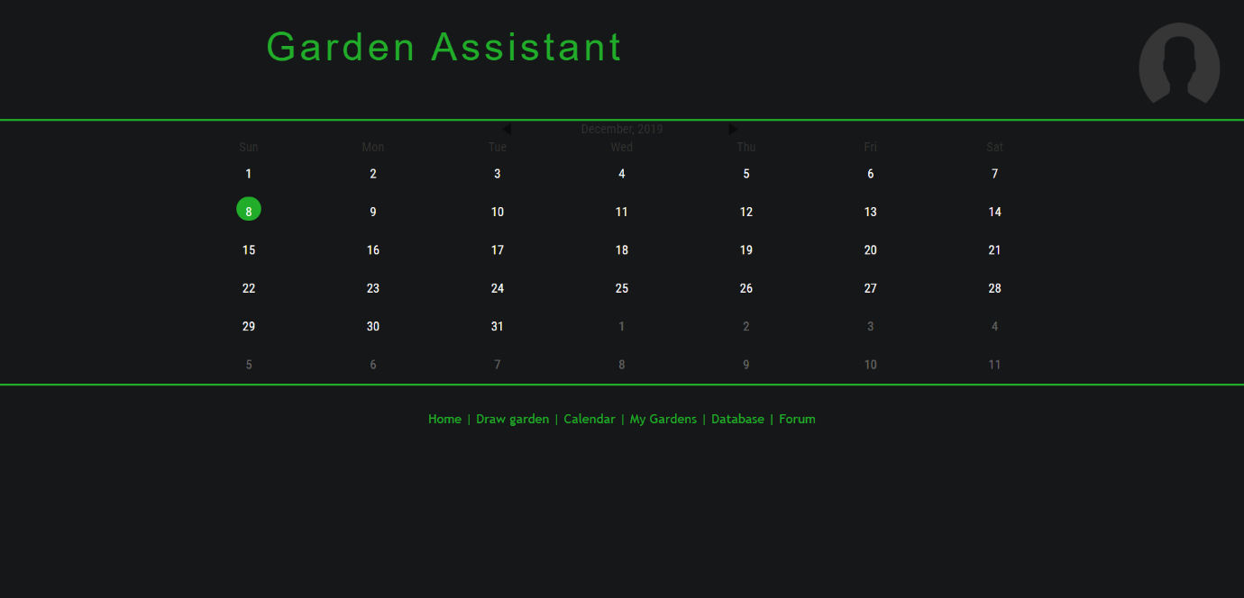

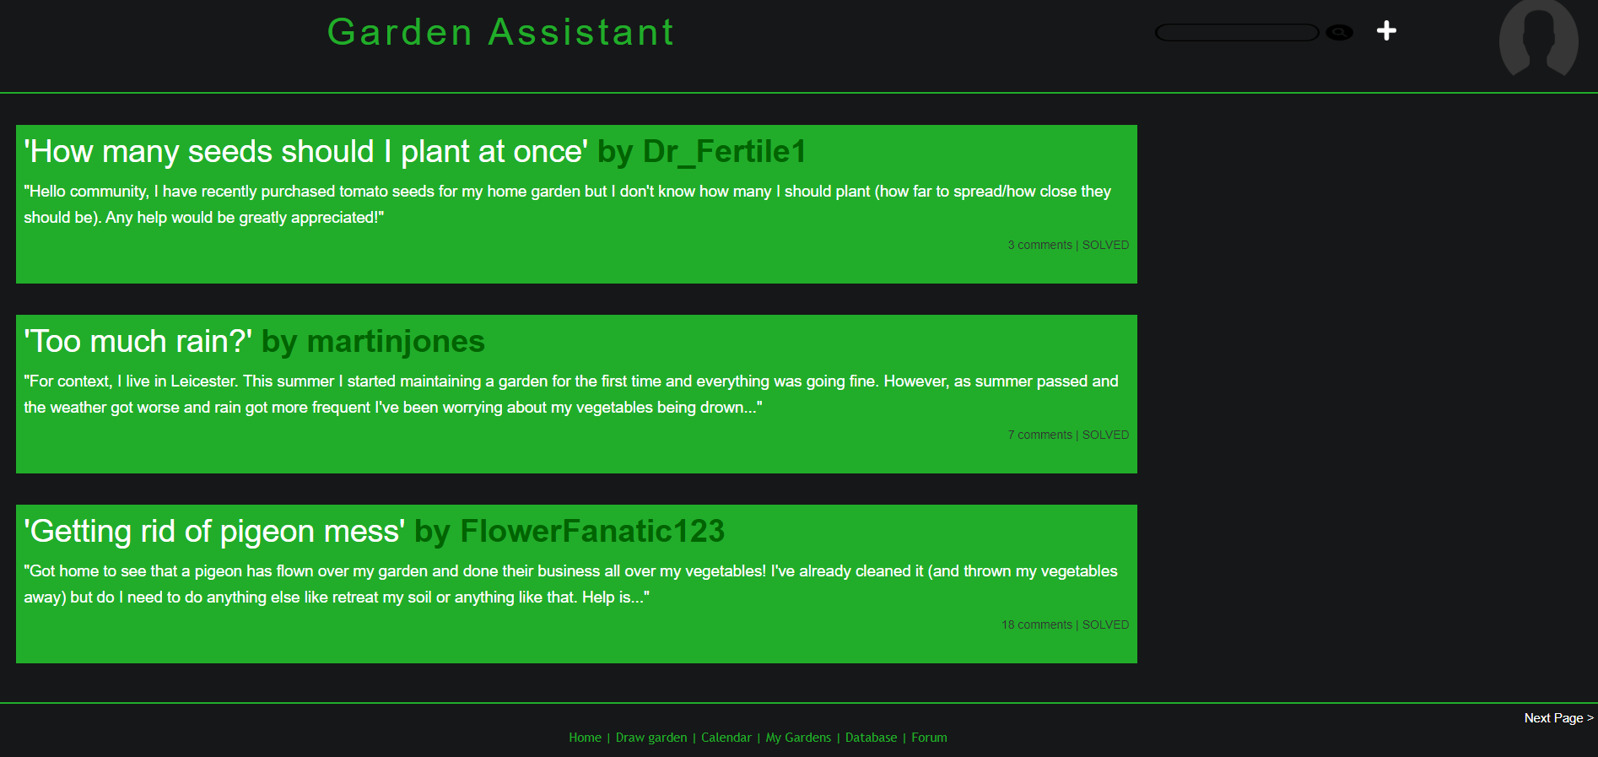

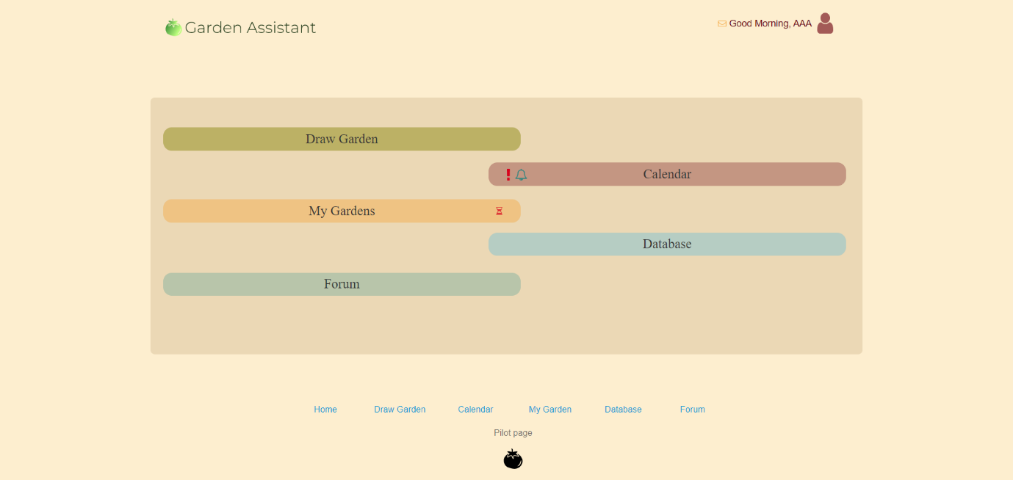Similar to the functional prototype, this prototype allowed for users to navigate through pages, but this gave a substantially better visualisation of what the final product would resemble.

